- Shout outs
  - Walk team has raised $1,079 for the Out of the Darkness Walk. Donations go until the end of the year.
  - Jonathan Truong and Thomas Chau being our newest black belts. Congratulations!
- Ideas for 2020
  - Katas
    - By the May testing, all students should be performing the katas, just like in the videos.
      - Black belts have until February to start learning the katas from the videos
    - Students that start in November are going to start learning the changes now to help eliminate the learning curve.
    - Our goal should be to teach in clusters versus individual moves.
  - 4-5 year old class
    - We are aiming to start the class in March 2020.
    - It’ll run from 9:30-10:15am; $30 a month on Saturdays.
    - Mostly going to be Sensei Britni and Miss Kortni running the class, but other instructors are welcome to help.
  - Yearly shirt
    - Each year, we will release a design for the year.
    - Sensei Hernandez is currently working on recreating an old design and it should be ready to go in February.
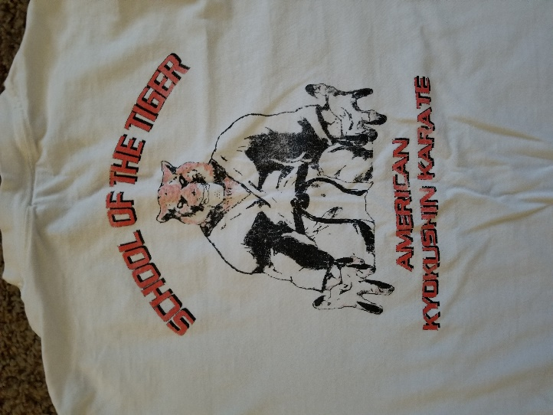
    - The shirts will cost $20 and be sold all year around this year and we’ll adjust as needed in 2021.
  - Black Bet Class
    - Sensei Britni will be buying a house in Elk Grove and has plans to turn the garage into a dojo for black belt classes.
    - Day and time will be decided closer to when we decide to start the class.
- Class Concerns
  - Counting
    - Had a parent complaint that we are too harsh on the students at the Pavilion compared to Wackford when they do not count loud enough to the point where students go home with no voice.
    - It was decided that to just give pushups to those not counting and putting in effort.
    - If needed, we can also tell brown belts that they will do pushups if the rest of the class is too quiet.
      - This was brought up because our brown belts are the ones not counting in class.
  - Announcement board
    - Most of our students don’t know anything about our style of karate/founder
    - Sensei Britni will create a board that will provide information about our classes, as well as announcements about the class.
    - Board will be done by November session
- Karate bonding
  - King’s Skate
    - Aiming for December 26, 27, or 30th to rent out King’s Skate for students and families
    - Sensei Britni will organize
- Other Concerns
  - Black Belts
    - Don’t be afraid to step up and show off because that’s how we inspire students to get black belts
    - Students loved seeing the jujitsu black belt testing
    - Sensei Britni and other senior instructors will help look for other opportunities for black belts to show off

Ending on another note: “If you do not overcome your tendency to give up easily, your life leads to nothing.” – Mas Oyama

